Get-ExifData.png

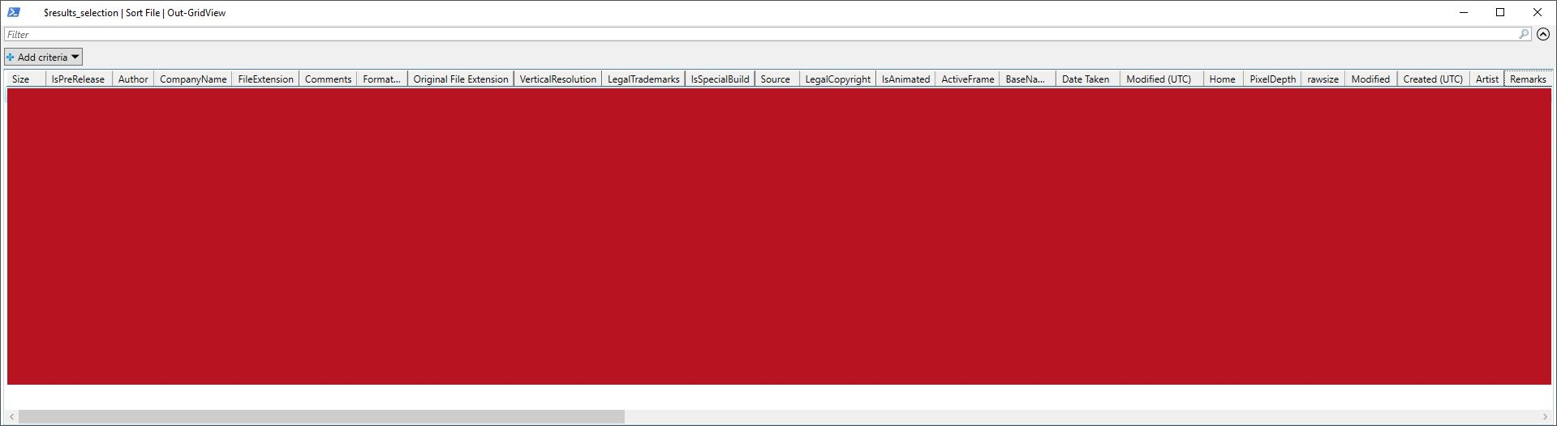

|  |  |
| --- | --- |
| Name | Value |
| Attributes | A |
| Bit depth | 24 |
| Computer | SRV19 (this PC) |
| Date accessed | 1-10-2021 13:20 |
| Date created | 1-10-2021 13:20 |
| Date modified | 30-9-2021 23:54 |
| Dimensions | ‪1919 x 526‬ |
| File extension | .png |
| Filename | Get-ExifData.png |
| Folder | example (C:\Users\lennard\Desktop\ExtractImageExifDataToWord) |
| Folder name | example |
| Folder path | C:\Users\lennard\Desktop\ExtractImageExifDataToWord\example |
| Height | ‎526 pixels |
| Horizontal resolution | ‎72 dpi |
| Item type | ImageGlass PNG File |
| Kind | Picture |
| Link status | Unresolved |
| Name | Get-ExifData.png |
| Owner | SRV19\lennard |
| Path | C:\Users\lennard\Desktop\ExtractImageExifDataToWord\example\Get-ExifData.png |
| Perceived type | Image |
| Rating | Unrated |
| Shared | No |
| Size | 122 KB |
| Space free | 31,9 GB |
| Space used | ‎73% |
| Total size | 118 GB |
| Type | ImageGlass PNG File |
| Vertical resolution | ‎72 dpi |
| Width | ‎1919 pixels |

image.jpg

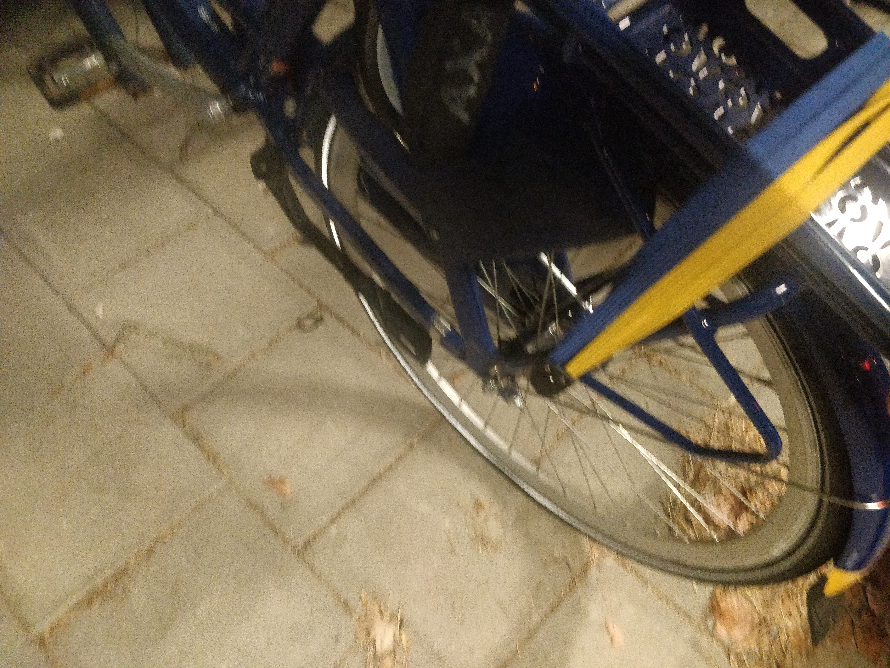

|  |  |
| --- | --- |
| Name | Value |
| 35mm focal length | 24 |
| Attributes | A |
| Bit depth | 24 |
| Camera maker | OnePlus |
| Camera model | ONEPLUS A5010 |
| Computer | SRV19 (this PC) |
| Date accessed | 1-10-2021 13:20 |
| Date created | 1-10-2021 13:20 |
| Date modified | 30-9-2021 23:54 |
| Date taken | ‎30-‎9-‎2021 ‏‎19:50 |
| Dimensions | ‪4608 x 3456‬ |
| EXIF version | 0220 |
| Exposure program | Unknown |
| Exposure time | ‎1/17 sec. |
| F-stop | f/1.7 |
| File extension | .jpg |
| Filename | image.jpg |
| Flash mode | No flash, compulsory |
| Focal length | ‎4 mm |
| Folder | example (C:\Users\lennard\Desktop\ExtractImageExifDataToWord) |
| Folder name | example |
| Folder path | C:\Users\lennard\Desktop\ExtractImageExifDataToWord\example |
| Height | ‎3456 pixels |
| Horizontal resolution | ‎72 dpi |
| ISO speed | ISO-2000 |
| Item type | ImageGlass JPG File |
| Kind | Picture |
| Link status | Unresolved |
| Name | image.jpg |
| Owner | SRV19\lennard |
| Path | C:\Users\lennard\Desktop\ExtractImageExifDataToWord\example\image.jpg |
| Perceived type | Image |
| Program name | OnePlus5T-user 10 QKQ1.191014.012 2010292059 release-keys |
| Rating | Unrated |
| Shared | No |
| Size | 6,74 MB |
| Space free | 31,9 GB |
| Space used | ‎73% |
| Total size | 118 GB |
| Type | ImageGlass JPG File |
| Vertical resolution | ‎72 dpi |
| Width | ‎4608 pixels |